Rest API Implementation

**Restaurants:**

1) **Saving Restaurant (POST)**

**URL :**

[http://localhost:8080/Restaurant_API/rest/restaurants/createrestaurant](http://localhost:8080/Restaurant_API/rest/restaurants/createrestaurants)

**Input : JSON**

**JSON FORMAT:**

[

{

"restaurantAddress":"ET lab,TX,72980",

"restaurantName":"KFC",

"restaurantStars":"5.0"

},

{

"restaurantAddress":"1000, Greek road",

"restaurantName":"Wendy's",

"restaurantStars":"3.0"

}

]

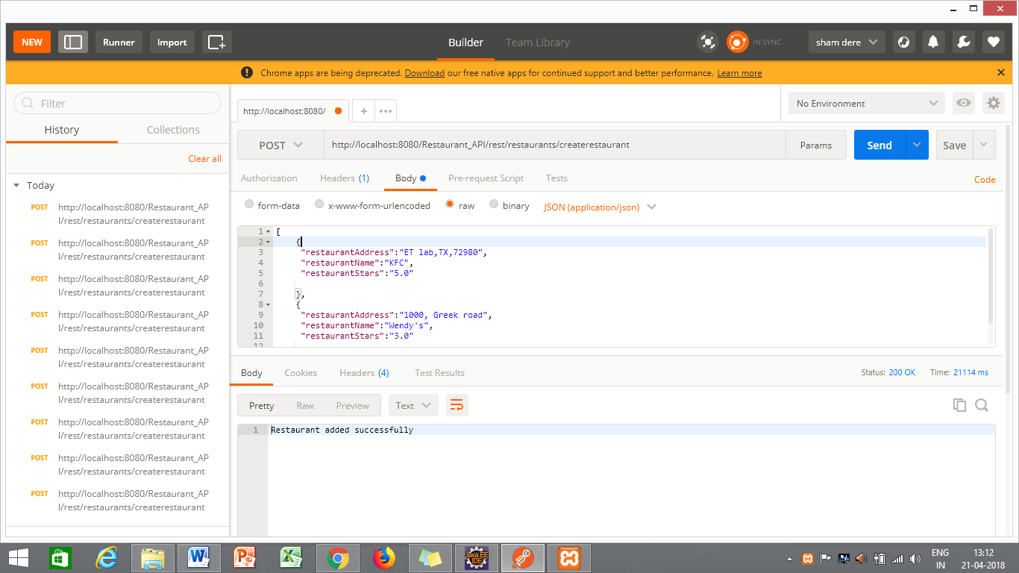

2) **Updating Restaurant (PUT)**

**URL :**

<http://localhost:8080/Restaurant_API/rest/restaurants/updaterestaurant>

**Input : JSON**

**JSON FORMAT:**

[

{

"restaurantAddress":"davis drive,TX,72980",

"restaurantName":"dong Wang",

"restaurantStars":"4.0"

},

{

"restaurantAddress":"Greek Dr drive,TX,72980",

"restaurantName":"mcdonald",

"restaurantStars":"1.0"

}

]

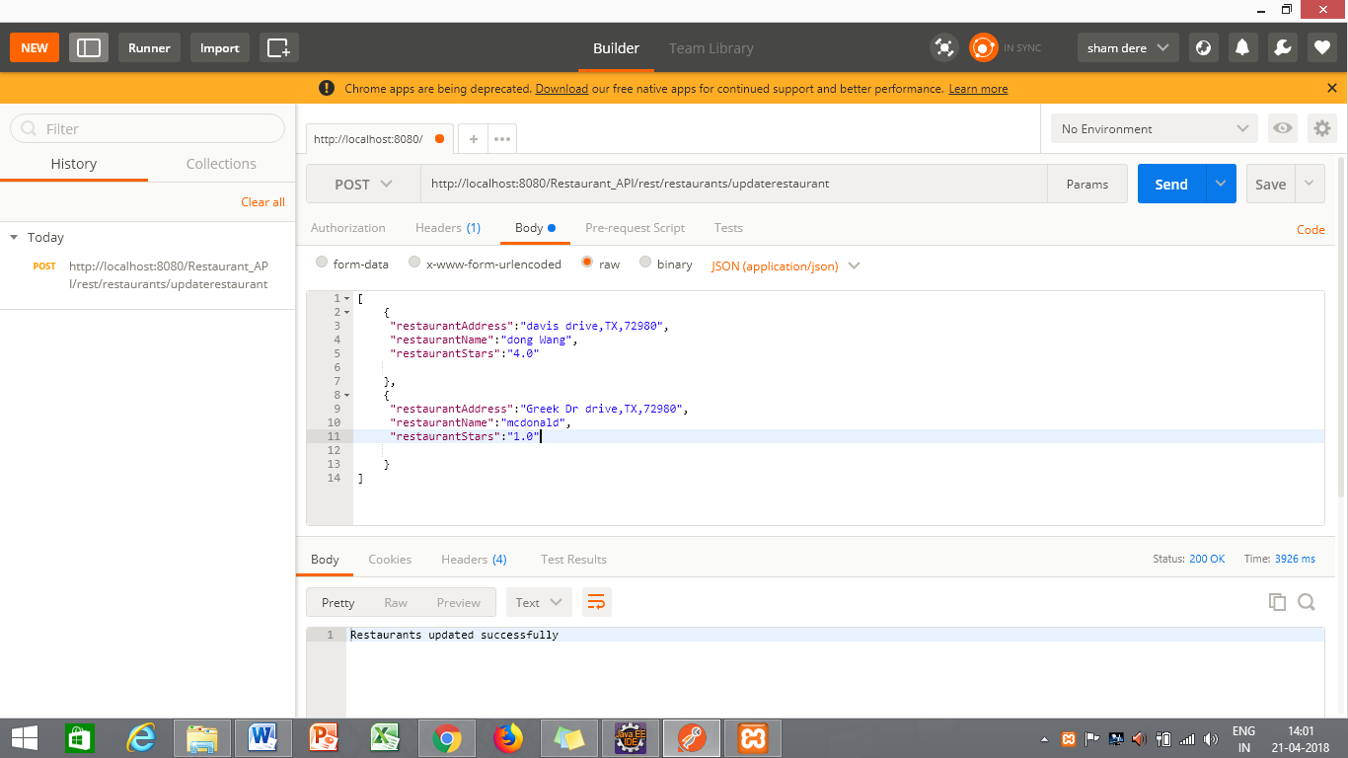

3) **Deleting Restaurant (DELETE)**

**URL :**

<http://localhost:8080/Restaurant_API/rest/restaurants/deleterestaurant>

**Input : JSON**

**JSON FORMAT:**

[

{

"restaurantName":"mcdonald"

},

{

"restaurantName":"kfc"

}

]

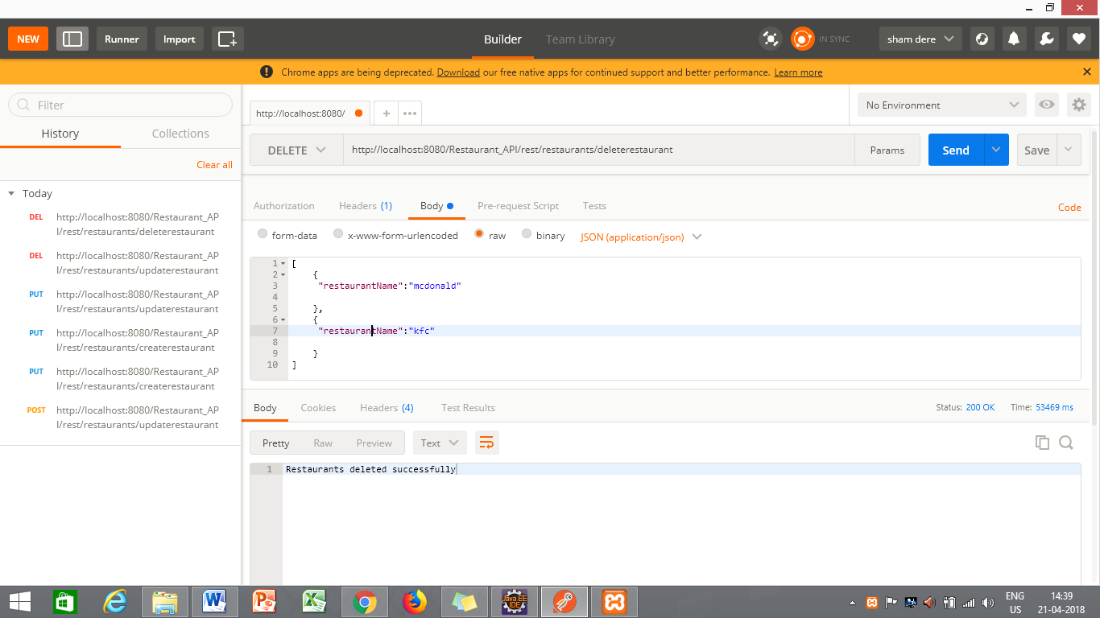

1. **Finding all restaurants (GET):**

**URL:**

<http://localhost:8080/Restaurant_API/rest/restaurants/findallrestaurants>

**Input : None**

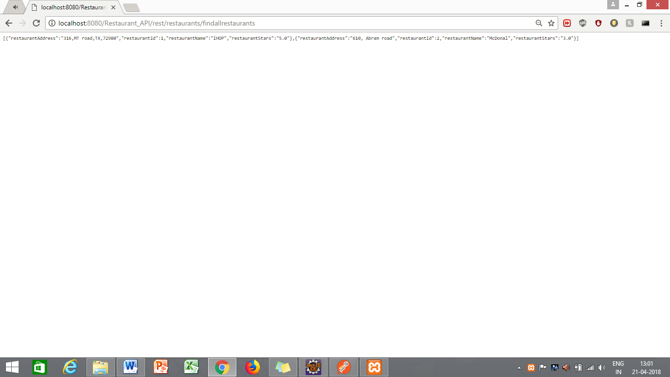

5) **Find the restaurant by name (POST)**

**URL :**

<http://localhost:8080/Restaurant_API/rest/restaurants/findrestaurant>byname

**Input : JSON(Restaurant)**

**Example:**

**[**

**{**

**"restaurants":**

**{**

**"restaurantAddress":"ERB Lab,TX,72980",**

**"restaurantName":"McDonald",**

**"restaurantStars":"5.0"**

**}**

**,**

**"menu" :**

**{**

**"menuType":"Breakfast",**

**"items": [**

**{**

**"itemName":"Burger",**

**"itemDescription":"Hot n Spicy",**

**"itemPrice":"5.9"**

**}**

**]**

**}**

**}**

**]**

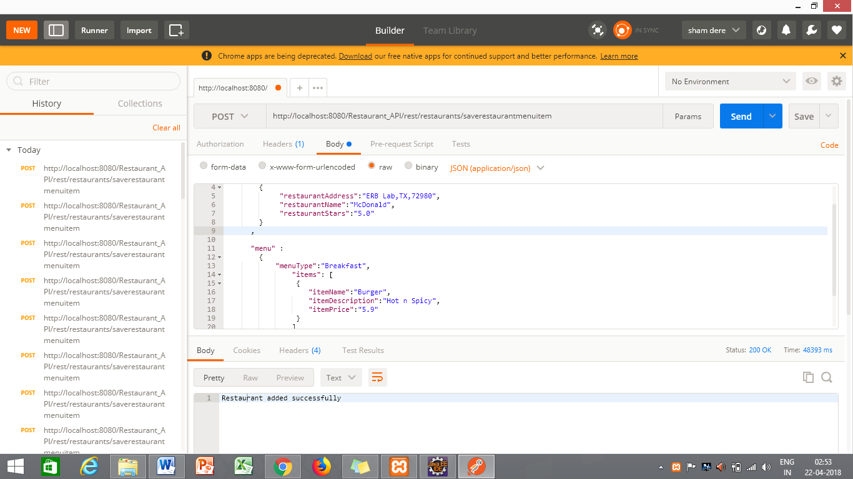

6) **Adding restaurant, menu for the restaurant, and items for the same (POST)**

**URL :**

<http://localhost:8080/Restaurant_API/rest/restaurants/saverestaurant>menuitem

**Input : String/ Text (Restaurant Name)**

**Example: “dong wang”**

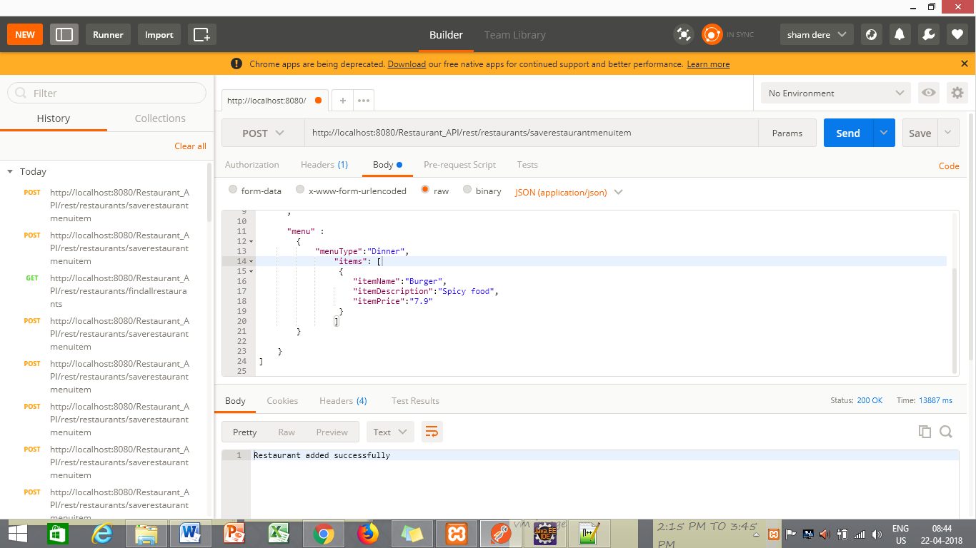

**Menu:**

1) **Saving Menu (POST)**

**URL :**

<http://localhost:8080/Restaurant_API/rest/menu/createmenu>

**Input : JSON**

**JSON FORMAT:**

[

{

"menuType":"Dinner"

},

{

"menuType":"Lunch"

}

]

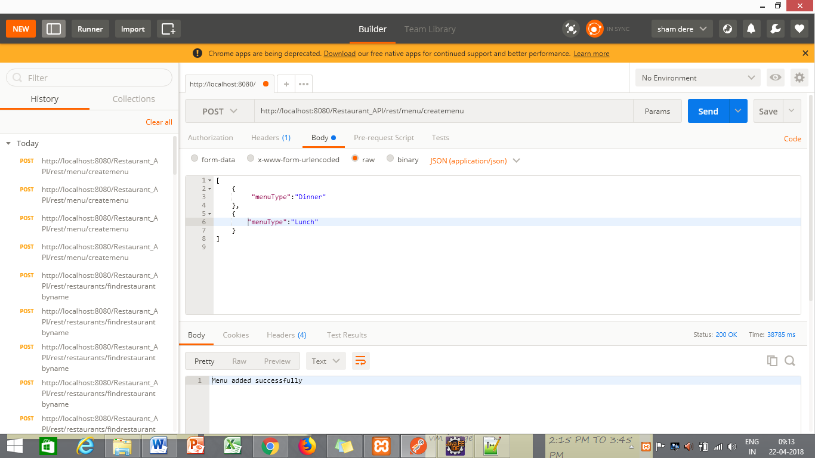

2) **Deleting Menu (POST)**

**URL :**

<http://localhost:8080/Restaurant_API/rest/menu/deletemenu>

**Input : JSON**

**JSON FORMAT:**

[

{

"menuType":"dinner"

}

]

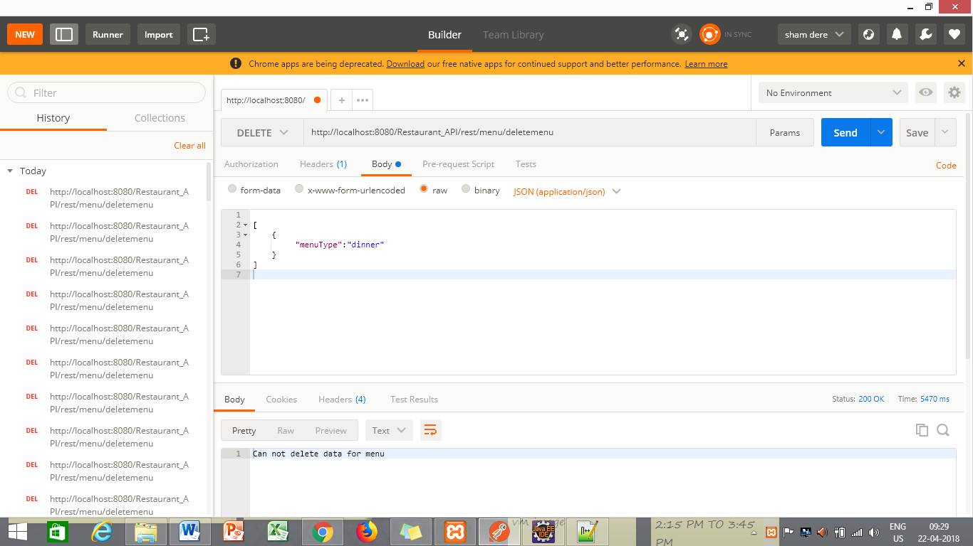

1. **Save all menu with items (POST):**

**URL:**

<http://localhost:8080/Restaurant_API/rest/menu/savemenuitem>

**Input : JSON**

**[**

**{**

**"menu" :**

**{**

**"menuType":"Breakfast",**

**"items": [**

**{**

**"itemName":"Burger",**

**"itemDescription":"Hot n Spicy",**

**"itemPrice":"5.9"**

**}**

**]**

**}**

**}**

**]**

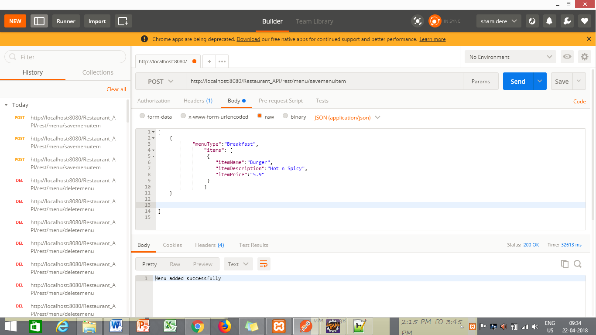

**Items:**

1) **Saving Item (POST)**

**URL :**

<http://localhost:8080/Restaurant_API/rest/items/createitem>

**Input : JSON**

**JSON FORMAT:**

[

{

"itemName":"Burger",

"itemDescription":"food",

"itemPrice":"5.0"

}

]

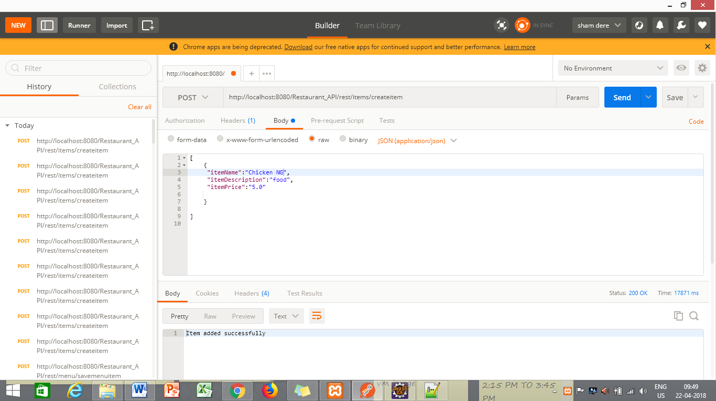

2) **Updating Item (PUT)**

**URL :**

<http://localhost:8080/Restaurant_API/rest/items/updateitem>

**Input : JSON**

**JSON FORMAT:**

[

{

"itemName":"chicken ng",

"itemDescription":"soup",

"itemPrice":"7.0"

}

]

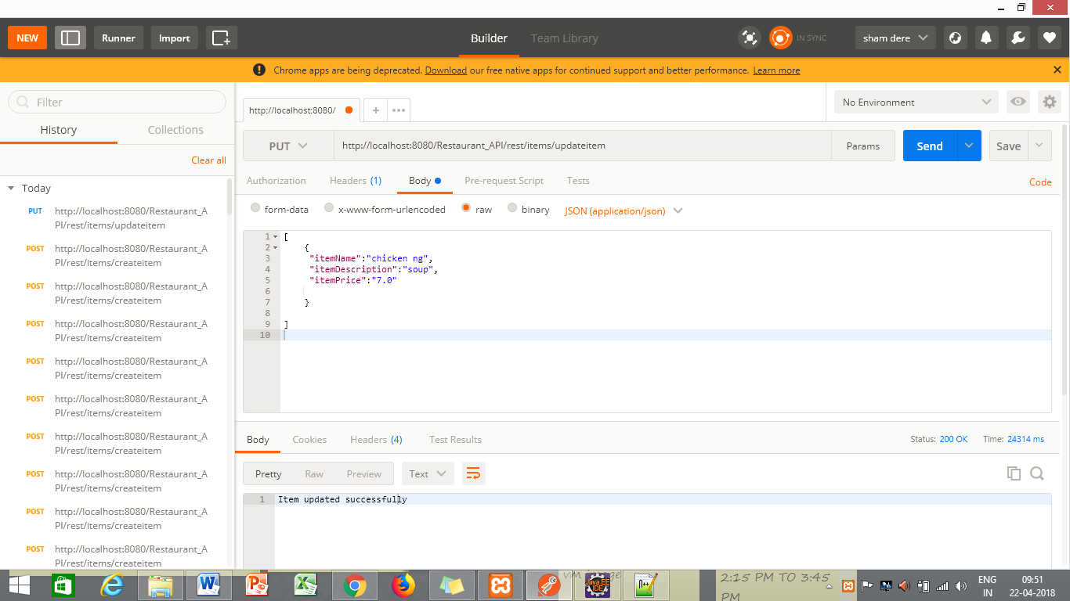

3) **Deleting Item (DELETE)**

**URL :**

<http://localhost:8080/Restaurant_API/rest/items/deleteitem>

**Input : JSON**

**JSON FORMAT:**

[

{

"itemName":"chicken ng"

}

]

